Knowledge and Technology

Bangladesh Army University of Engineering & Technology



Department of Computer Science and Engineering

A Project Report on

**E-commerce Website**

Supervised By

Md. Omar Faruq

Lecturer,

Department of CSE, BAUET

Mst. Irin Sultana

Lecturer,

Department of CSE, BAUET

Submitted By

Bonna Khatun

ID: 19104015

K.M. Ferdous Zaman Wahid

ID: 19104033

Department of Computer Science and Engineering

Bangladesh Army University of Engineering & Technology

October,2022

*KNOWLEDGE & TECHNOLOGY*

# **Bangladesh Army University of Engineering & Technology**



**Department of Computer Science and Engineering**

**CERTIFICATE**

This is to certify that the project entitled “**BAUET Meet**” by “**Bonna Khatun**”, **ID No.: 19104015**, “**K.M. Ferdous Zaman Wahid**”, **ID No.: 19104033**, has been accepted as satisfactory in partial fulfillment of the requirement for the course CSE-4102, “System Analysis and Design Sessional” on **October, 2022**.

Signature of Supervisor

**…………………………..**

Md. Omar Faruq

Lecturer,

Department of Computer Science and Engineering

Bangladesh Army University of Engineering & Technology

**…………………………..**

Mst. Irin Sultana

Lecturer,

Department of Computer Science and Engineering

Bangladesh Army University of Engineering & Technology

*KNOWLEDGE & TECHNOLOGY*

# **Bangladesh Army University of Engineering & Technology**

# 

**Department of Computer Science and Engineering**

**DECLARATION**

I thereby declare that our project entitled “**BAUET MEET”** is the result of our work. I also ensure that it does not previously submitted or published elsewhere for the award of any degree or diploma.

The work has been accepted for the degree of Bachelor of Science in Computer Science and Engineering at Bangladesh Army University of Engineering & Technology (BAUET)

**Author(s)**

**…………………………..**

**Bonna Khatun**

**…………………………..**

**K.M. Ferdous Zaman Wahid**

**Acknowledgement**

We are showing our humble gratitude to the author of various papers from which we received help. We are also having some respect in our heart for the google meet, because we have built a identical clone of google meet with some marginal innovations. And also, we are thanking each-other as we have worked as a team, except our team work we would not have finished our project with in the given deadline.

Ms. Bonna Khatun

ID No.: 19104015

Mr. K.M. Ferdous Zaman Wahid

ID No.: 19104033

**Abstract**

Web-based project management software is a type of software that allows users to work on collaborative projects online. This software allows streamlining distributed workflows, replacing email operations and improving remote collaborative work. Web applications include online forms, shopping carts, word processors, spreadsheets, video and image editing, email programs, etc. Our purpose of making this web-based E-commerce website is to provide services and sell products online through our E-commerce shop. We are focusing to target audiences who are not willing to buy products or take services from any local shop. This will save time also. We have used popular programming language HTML, CSS, JavaScript, PHP to build this web-based project. As a result, we get a well-designed and responsive website where customers can buy exclusive products and services without any hazard.

|  |  |  |
| --- | --- | --- |
| **List of Contents** | | |
| Chapter | Title | Page No. |
|  | Certificate | ii |
| Declaration | iii |
| Acknowledgement | iv |
| Abstract | v |
| List of contents | vi |
| List of figures | vii |
| List of Tables | viii |
| 1 | Introduction | 1-2 |
|  | 1.1 Introduction | 1 |
| 1.2 Objectives | 1 |
| 1.3 Advantages | 2 |
| 1.4 Disadvantages | 2 |
| 1.5 Conclusion | 2 |
| 2 | Background Study | 3-4 |
|  | 2.1 Introduction | 3 |
| 2.2 Existing System | 3 |
| 2.3 Conclusion | 4 |
| 3 | Proposed Model | 5-9 |
|  | 3.1 Introduction | 5 |
| 3.2 Flowchart | 6 |
| 3.3 Use case diagram | 7 |
| 3.4 Entity Relation(E-R) Diagram | 8 |
| 3.5 Methodology | 9 |
| 3.6 Conclusion | 9 |
| 4 | Design & Implementation | 10-25 |
|  | 4.1 Introduction | 10 |
| 4.2 Visual Representation | 10-23 |
| 4.3 Database | 24-25 |
| 4.4. Conclusion | 25 |
| 5 | Conclusion and Future Scope | 26 |
|  | 5.1 Introduction | 26 |
| 5.2 Comparison | 26 |
| 5.3. Future Work | 26 |
| 5.4 Conclusion | 26 |
|  | **List of figures** |  |
| **Figure No.** | **Title** | **Page No.** |
| 3.1.1 | Agile Process Model | 5 |
| 3.2.1 | Dataflow diagram of proposed system | 6 |
| 3.3.1 | Use case diagram of proposed model | 7 |
| 3.4.1 | E-R Diagram | 8 |
| 4.2.1 | Home Page-I | 10 |
| 4.2.2 | Home Page-II | 11 |
| 4.2.3 | Home Page-III | 12 |
| 4.2.4 | Blog Page-I | 13 |
| 4.2.5 | Blog Page-II | 13 |
| 4.2.6 | Blog Page-III | 14 |
| 4.2.7 | Blog Page-IV | 14 |
| 4.2.8 | Blog Page-V | 15 |
| 4.2.9 | About Us page-I | 16 |
| 4.2.10 | About Us page-II | 16 |
| 4.2.11 | Contact page-I | 17 |
| 4.2.12 | Contact page-II | 17 |
| 4.2.13 | Contact page-III | 18 |
| 4.2.14 | Contact page-IV | 18 |
| 4.2.15 | Product page-I | 19 |
| 4.2.16 | Product page-II | 19 |
| 4.2.17 | Product page-III | 20 |
| 4.2.18 | Product page-IV | 20 |
| 4.2.19 | Cart page-I | 21 |
| 4.2.20 | Cart page-II | 21 |
| 4.2.21 | Cart page-III | 22 |
| 4.2.22 | Signup Page | 23 |
| 4.2.23 | Login Page | 23 |

**List of Table**

|  |  |  |
| --- | --- | --- |
| **Table No.** | **Title** | **Page No.** |
| 4.3.1 | Product Table | 24 |
| 4.3.2 | Use details Table | 24 |
| 4.3.3 | User order details table | 25 |

**Chapter 1**

**Introduction**

* 1. **Introduction**

Web-based applications are a specific kind of software that enables users to communicate with a distant server using a web browser interface. They have gained tremendously in popularity in recent years, replacing desktop applications and turning into an essential tool for both small and large organizations worldwide. [1]

Any application that is used to access data through a network utilizing HTTP and is not stored in a device’s memory is referred to as a web-based application. Frequently, web browsers are used to execute web-based applications. Web-based applications can alternatively be client-based, in which case just a tiny portion of the software is downloadable to the user’s computer and all processing is carried out on an external server through internet connection. We can also refer this as web app.

The usage of terminology like web-based, internet-based, and cloud-based when discussing applications causes a lot of misunderstanding. Applications that interact with users using HTTP protocol are all considered web-based applications. Both simple applications like Flash games, online calculators, calendars, and other similar tools, as well as more complex ones like web-based word editors and spreadsheet programs, fall under this category. [2]

* 1. **Objectives**

The standard front-end and back-end web development technologies are used in web applications. Web applications and webpages are conceptually closely connected, therefore, there are many similarities between the two. When mapped to the applications document root, a web application’s directory structure is completely accessible. JS files, HTML files, and static files such as image files are all found under the document in its whole and compressed form is included in a ZIP file. [3]

**1.3 Advantages**

* Web-based applications are cost-effective
* No need to update often
* There is no need of downloading any big files
* Very Easy to run

**1.4 Disadvantages**

* Always need a proper internet connection
* Often operates at a slower speed than any other apps relatively
* Less secure to protect important and confidential data
* Restricted functionality for non-native users

**1.5 Conclusion**

The popularity of web development is growing as a result of its adaptability, speed, and affordability. Depending on the designer and the intended audience, web design services are often carried out for a range of purposes. Web applications, however, have their own set of advantages and disadvantages, much like other technical breakthroughs. In order to understand the benefit of web applications we have to watch out the pros and cons of it. [4]

**Chapter 2**

**Background Study**

**2.1 Introduction**

The basic idea of our project is to develop an E-commerce website where people can get their likely clothing products and can get best swing services. The e-commerce website will give retailers a channel via which they may buy and sell their goods. It will provide online shoppers an interface via which they can buy goods from both formal and unauthorized sellers. A few parts of the e-commerce website will be created using PHP, a very well-liked and adoptable e-commerce programming language. Customers can access information about the numerous items for sale on the website. Prices, product descriptions, stock availability, and product images will all be included in the information. [5]

HTML is the standard markup language to develop web pages. It stands for “Hyper Text Markup Language”. To describe the structure of a web page HTML is used. Precisely, HTML elements express the browser how to display the content of the website. [6]

CSS is the language that is used to style an HTML document. It stands for “Cascading Style Sheets”. It describes how HTML elements of the web pages should be displayed in the web browser. [7]

Purpose of the development of this project is to gather sellers and customers from different community in one platform, so that they can trade with each other as they can’t do that locally for many undoubted reasons. We have used HTML to create the initial structure of our web pages and CSS to design the web pages. We also have used JavaScript to set the mechanism for the front-end beauty. And finally, we have used PHP programming language to connect our database to the website so that each and every can be stored securely.

**2.2 Existing System**

The E-commerce globally has been very important for the markets in the last few years, since the beginning of internet many companies started to move to this new type of media that makes in some way easily for the people not only to make or create businesses but for everything. Electronic commerce is impacting positively on the business and enterprises of local trade as they are shifting business to online to sale their product or services as well as they do locally. Means the simple way that the use of this tool has facilitated and has increased the sales and business between individuals and companies.

Many companies are creating their online shops from where customers can buy products and  
give their feedback. Also, the platform can recommend products or services as they search  
based on their choices. Customers can search products as their wish and as a result they can get images of the required product with price, sizes and details of the product. Customers can order from the site and can review the product on the site. Some existing systems are **Daraz, Alibaba, Aliexpress, Amazon, Flipkart,** etc.

**2.3 Conclusion**

Creating an E-commerce website, we are targeting to attract audiences who are willing to buy products or services online. The main purpose of our project is to build an online platform, where people from different community can buy and sell products or services. To achieve this goal, we have already developed an e-commerce website where the product of different sellers will be displayed and customers can buy their chosen products from the listing.

**Chapter 3**

**Proposed Model**

**3.1 Introduction**

For an E-commerce web frame-works the best process model used is Agile model. So, we have used the Agile process model to develop our online based e-commerce website. Agile methodology is a project management system that advocates for self-organizing, adaptive planning, flexible development, continuous changes, and early delivery. The main idea is to have teams work with shorter and multiple deadlines. This allows for more feedback from end-users, while also providing then a working product sooner, even if it isn’t necessarily the final product. [8]

We had decided to use this methodology after investigating its advantages. Advantages are as follows:

* Teams can be more flexible as the users’ needs change over time
* Users to get a working product much faster
* Teams can create a better final product for the end-users

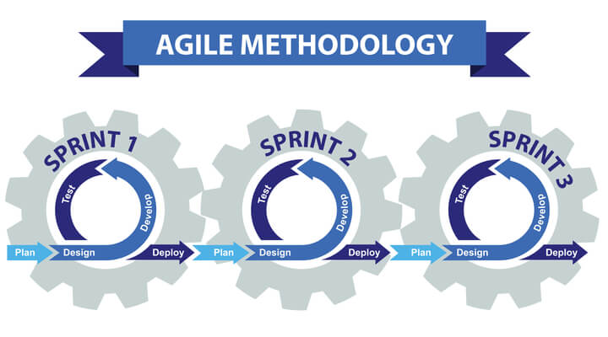

Figure 3.1.1: Agile Process Method

The Agile technique might be a terrific way to enhance our project internal procedures. It can increase efficient communication inside our project and enhance our team’s responsiveness and adaptability. Overall, the result we get after using agile model focusing on the advantages, we may have improved products and contented customers.

**3.2 Flow-Chart**

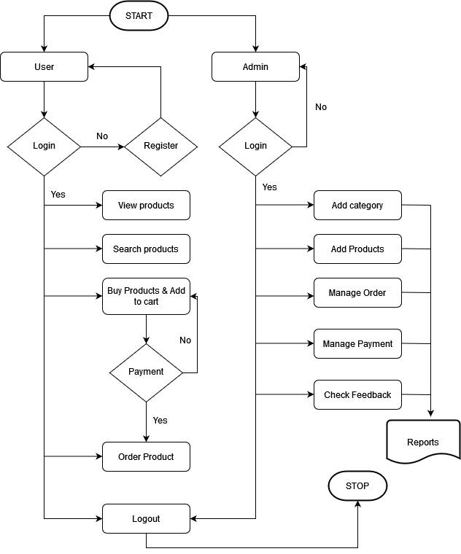

Figure 3.2.1: Data-flow of the project

This is the data flow diagram of our project. As the diagram follows, user have to register first and then have to login. After login to the system user can search products, view products, add products to the cart and then can order products after choosing payment option. As per the diagram admin can login, add products, manage orders, manage payments and can check feedbacks.

**3.3 Use case Diagram**

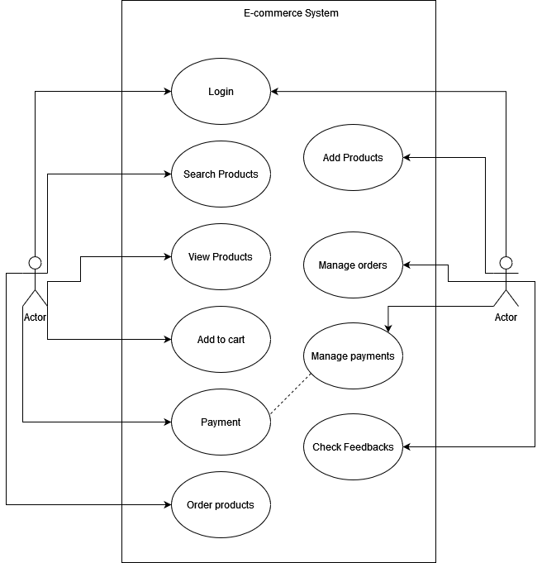

Figure 3.3.1: Use case Diagram of E-commerce system

In the above figure, attached diagram is known as Use-case diagram of any system. We have provided well designed use-case diagram of our e-commerce system by mentioning the working parts of users and admin alongside.

**3.4 Entity Relation(E-R) Diagram**

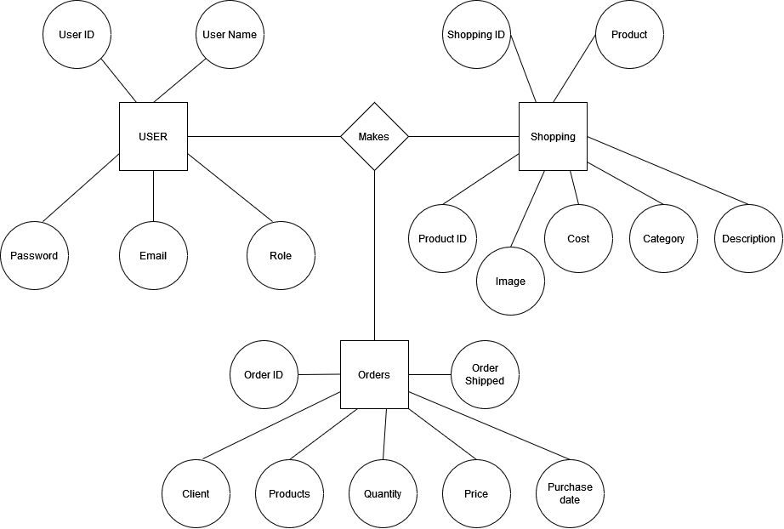

Figure 3.4.1: Entity Relation Diagram of our E-commerce website

Above figure represents the Entity Relation diagram of our project, E-commerce website platform. The diagram expresses each and every entity of our database and present the relations between every part of the working product. User account has user-name, user-id, password, email. So that, user can login using those details. In the other part, product details

of our platform noted in here. And the last part is order section, where the details of the ordered product and the details of the user who have ordered the product. Product name, image, quantity, price and purchased date is included in this section. The complete details of each entity-relationship had been described in this diagram.

**3.5 Algorithm**

Step 1: At first you have to enter the website via link.

Step 2: To order something you have to search products according to keywords.

Step 3: After choosing products you can add some to the carts.

Step 4: From the cart you can go to check-out and buy that product.

Step 5: If you have an account, you can directly buy products. But if you don’t, you have

to create one.

Step 6: To register you will need contact details: phone no., address, e-mail.

Step 7: After registering you have to login. To login you have to use user name and

password.

Step 8: Then from the product page user can add product to the cart.

Step 9: From the cart section user can go through the order and payment system to order product/s.

Step 10: After completing the order user can track order.

**3.6 Conclusion**

In this section, we have discussed about the Dataflow diagram, Use-case diagram, E-R diagram, and step by step algorithm of our project. These diagrams represent the dataflow, use-case, and entity relationship respectively. These diagrams will clarify each part of our project.

**Chapter 4**

**Design and Implementation**

**4.1 Introduction**

The implementation phase involves putting the project plan into action. It’s here that the project manager will coordinate and direct project resources to meet the objectives of the project plan. As the project unfolds, it’s the project manager’s job to direct and manage each activity, every step of the way. Our project is implemented as the requirements. All the options proposed in the design is implemented here.

**4.2 Visual Representation of System**

In this part of the book, the visual representations of the system will be discussed. That means this section will display the images of every page of the website developed by our group.

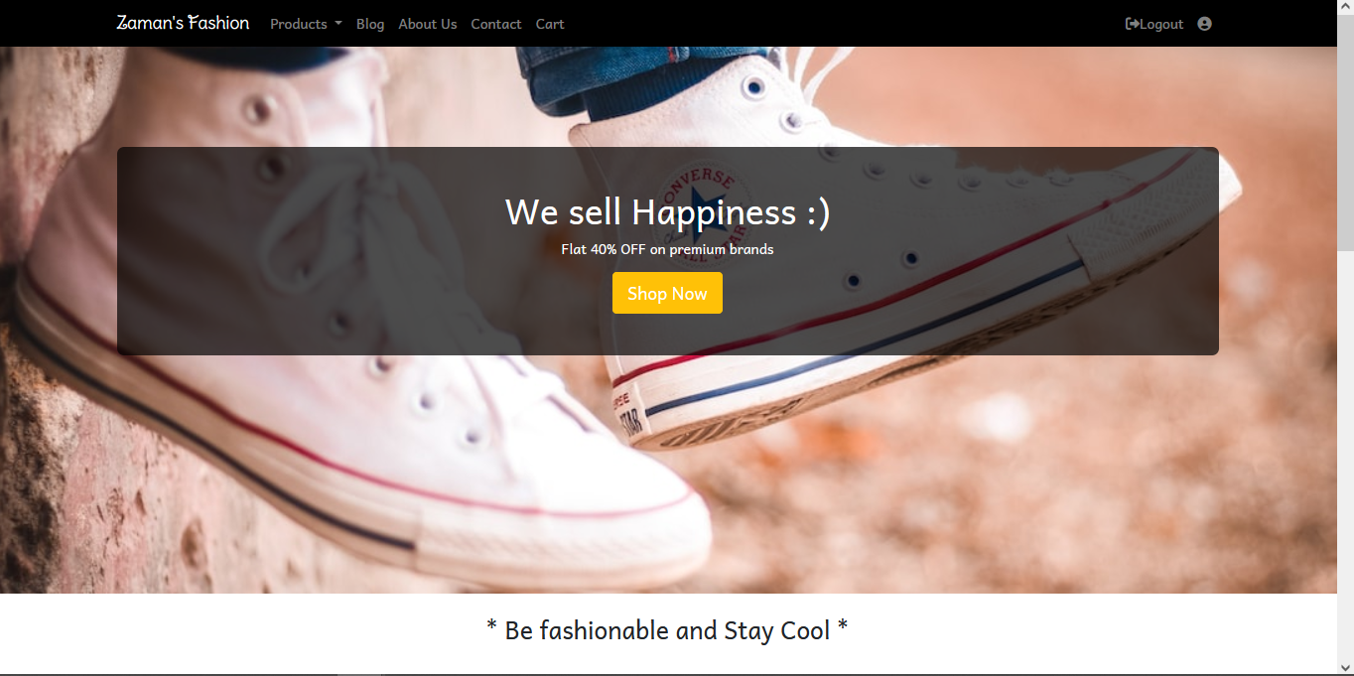

Figure 4.2.1: Home Page-I

The above screenshots describe the visual representation of the Home page of our system. At the top of the Home page there is a navigation bar in which there are products section, blog section, about section, contact section, cart section and the logo section. From the nav bar we can go to every page of the website by clicking on them. We can go to about page, contact page as well as to the blog page.

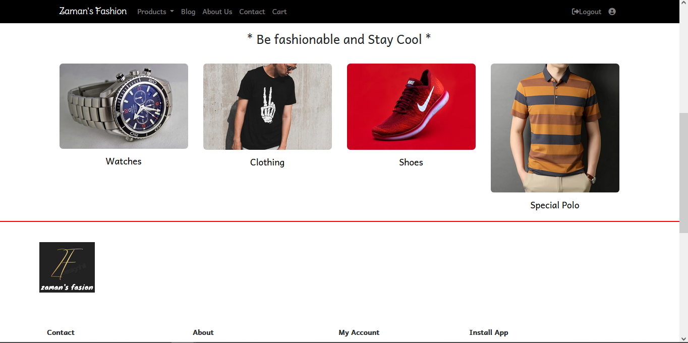

Figure 4.2.2: Home Page-II

Now, if we scroll down little-bit we can see the features products to sell. There are categorical products displayed that are for sell. And there is a banner where over the banner there is a button where if we click it will guide us to the product page from where we can buy products. These featured products are the overall category of the products that are displayed in the product page.

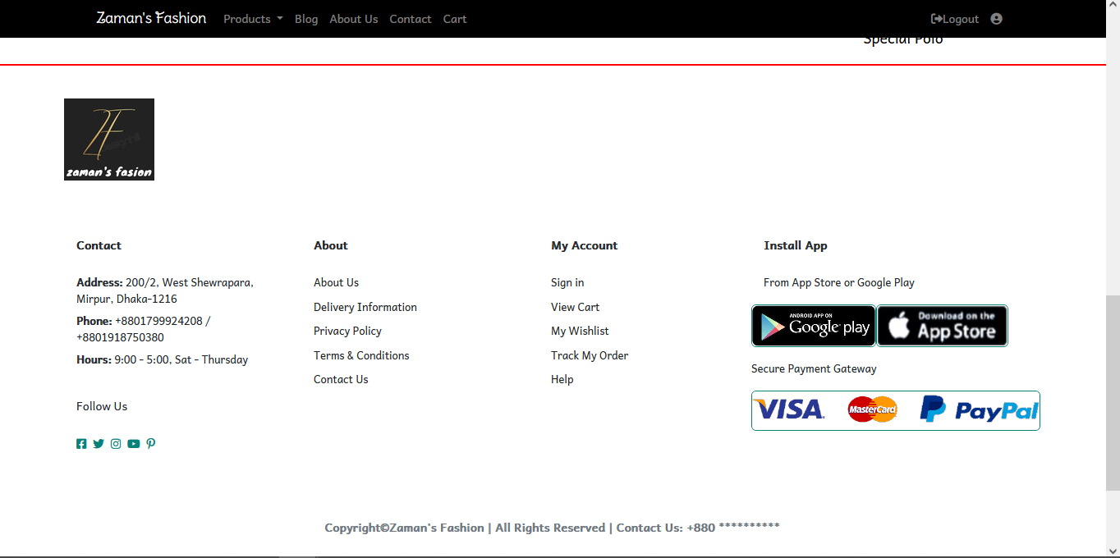

Figure 4.2.3: Home Page-III

At the end on the Home page we can see that there is a footer added. In that footer, every detail of the shop is given. Also, there is given the links of the pages we can visit through our website. Also, there are the details of the online account handles are provided with the proper address of the physical shop. Payment gateways are also shown in the footer section.

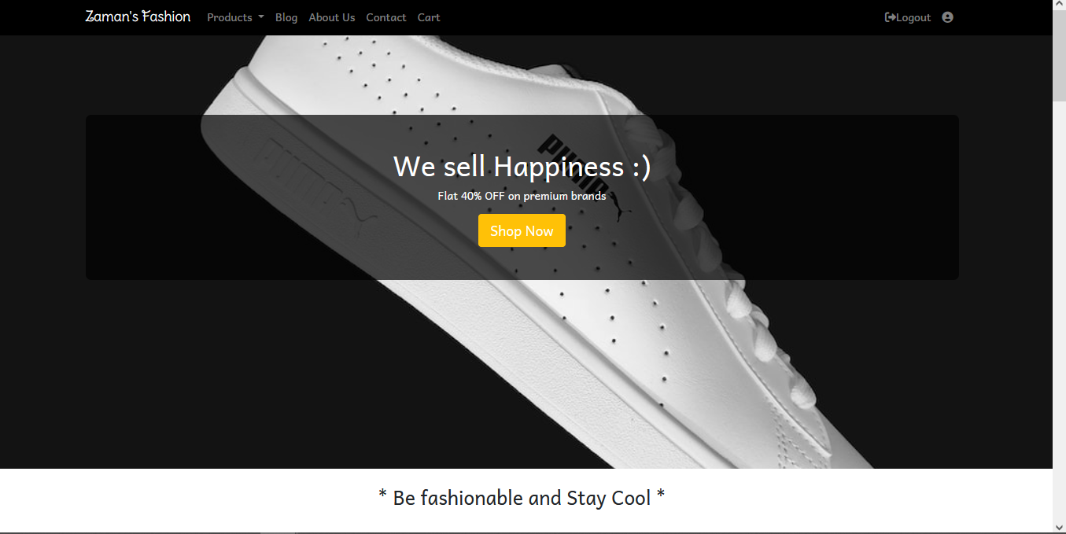

Figure 4.2.4: Blog page-I

These screenshots represent the blog page of the website where there is various blog are linked for clothing related knowledge. Also, from the blog page we can jump into the product page by clicking on the “Shop Now” button displayed on the banner.

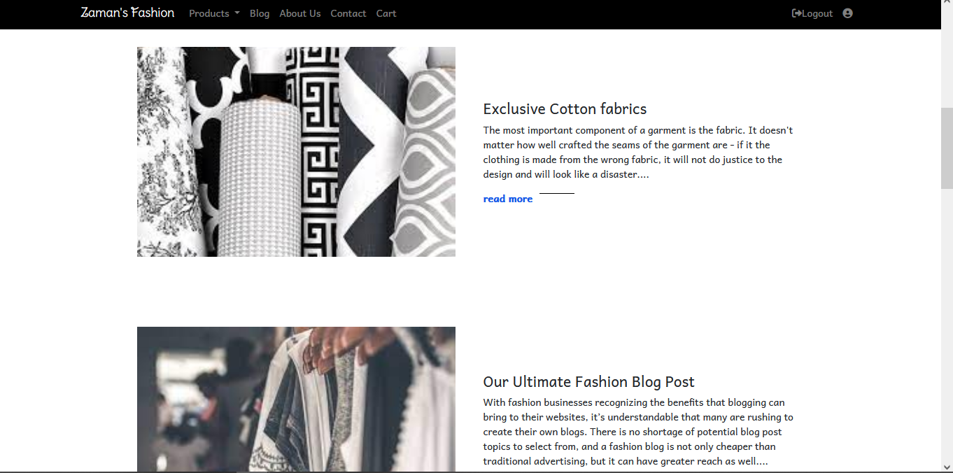

Figure 4.2.5: Blog page-II

From this page customers can view the blogs written for the knowledge of the cloths and fabrics. And also, they can gather some knowledge about the sewing process of the cloths at the industrial level.

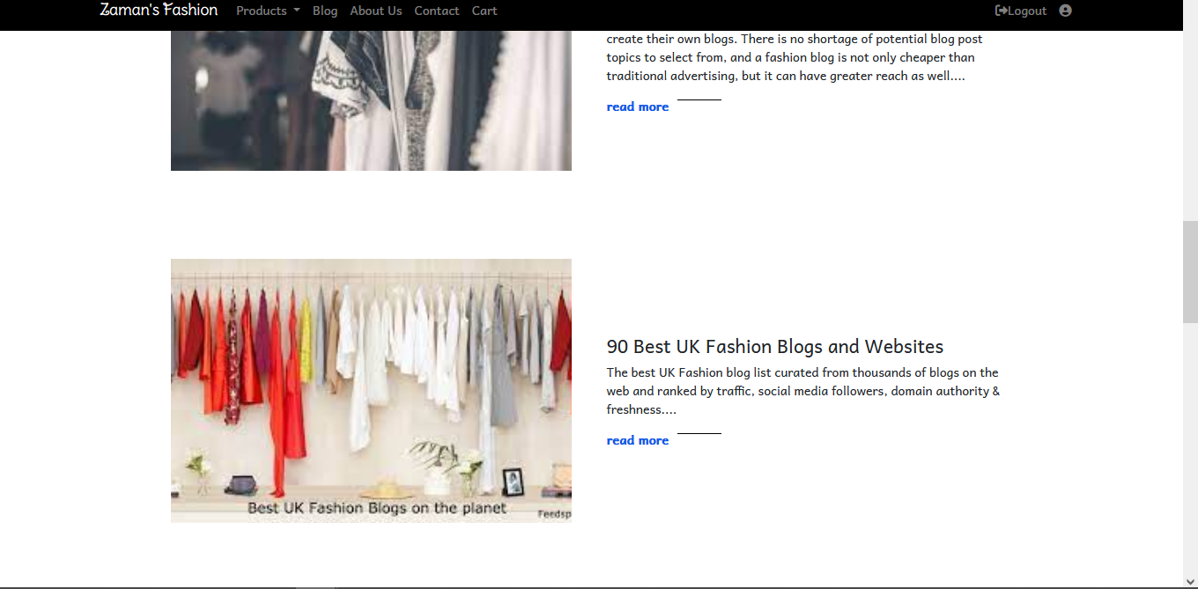

Figure 4.2.6: Blog page-III

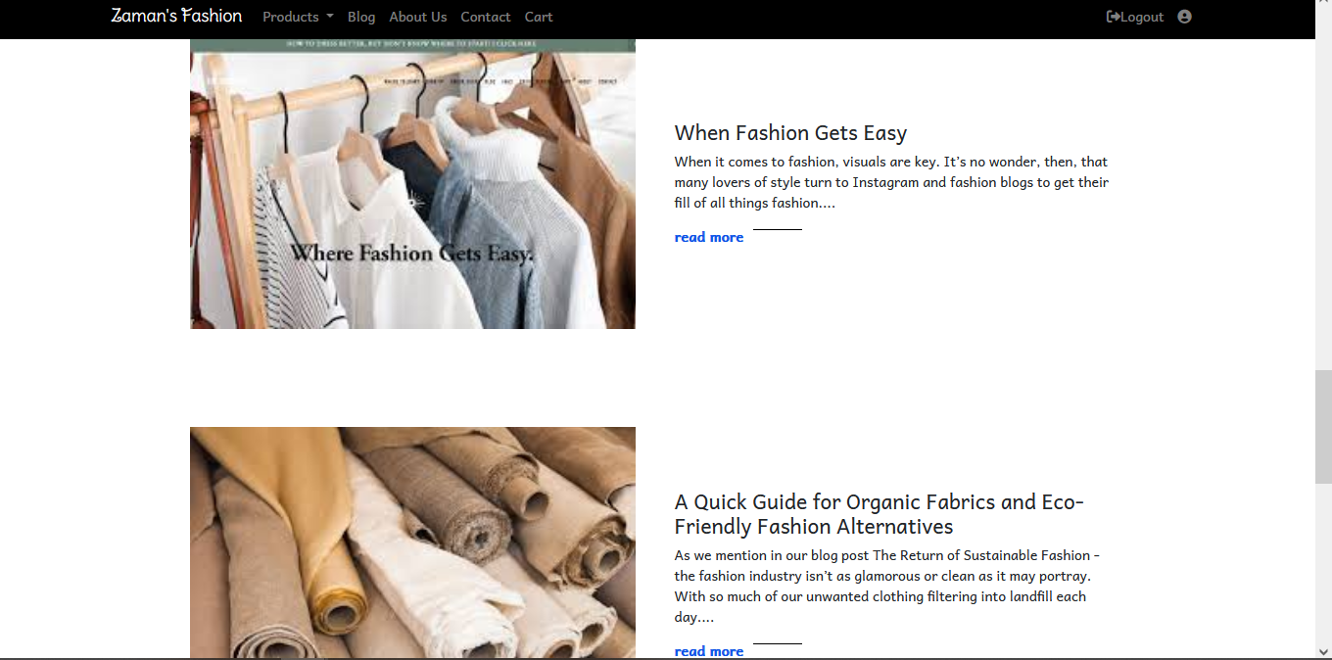

Figure 4.2.7: Blog page-IV

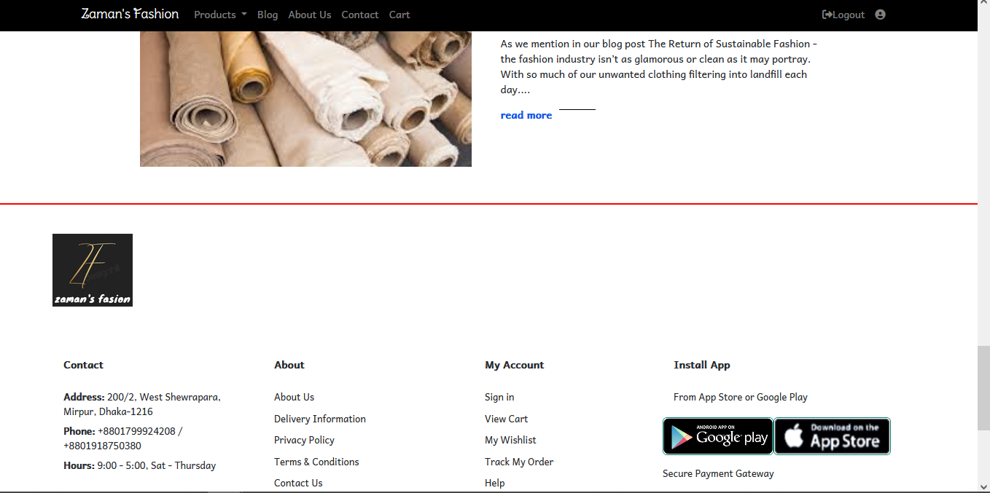

Figure 4.2.8: Blog page-V

And at the end of the blog page there is the regular footer as always, where the details of the website shop is provided with proper addresses and contact numbers.

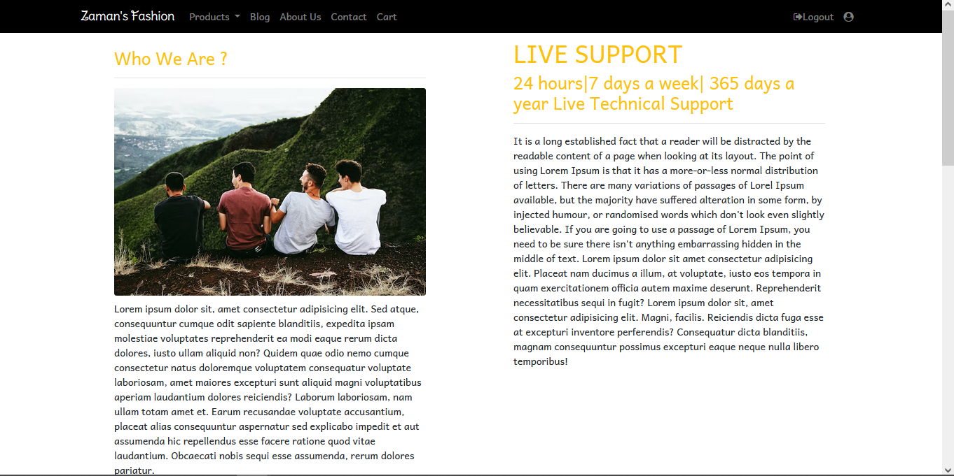

Figure 4.2.9: About Us page-I

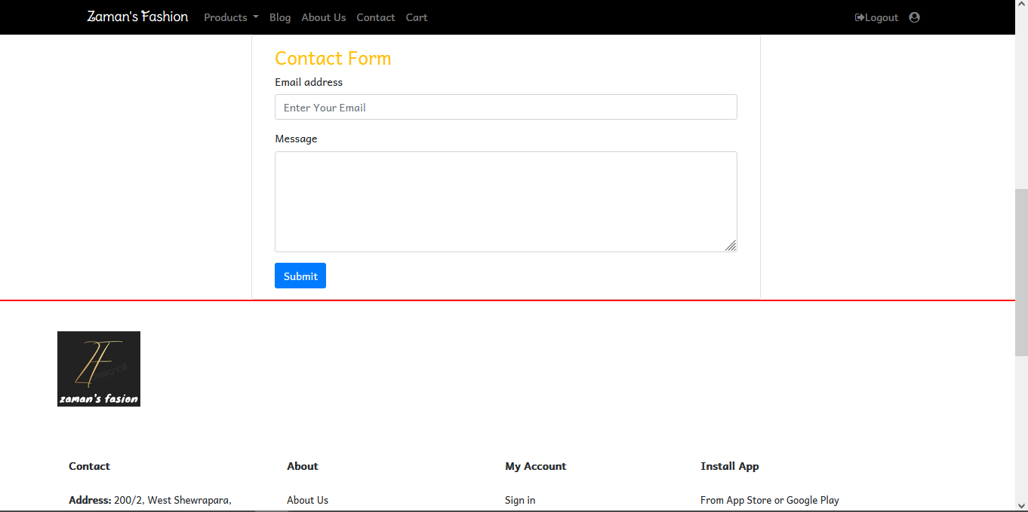

Figure 4.2.10: About Us page-II

This page describes the details of our website. What is the purpose of this platform and what is the goal of the developer are explained in this section of the website. There is a form at the middle of the page using which customers can ask direct questions to the developer. And as always there is the footer added at the end of the page.

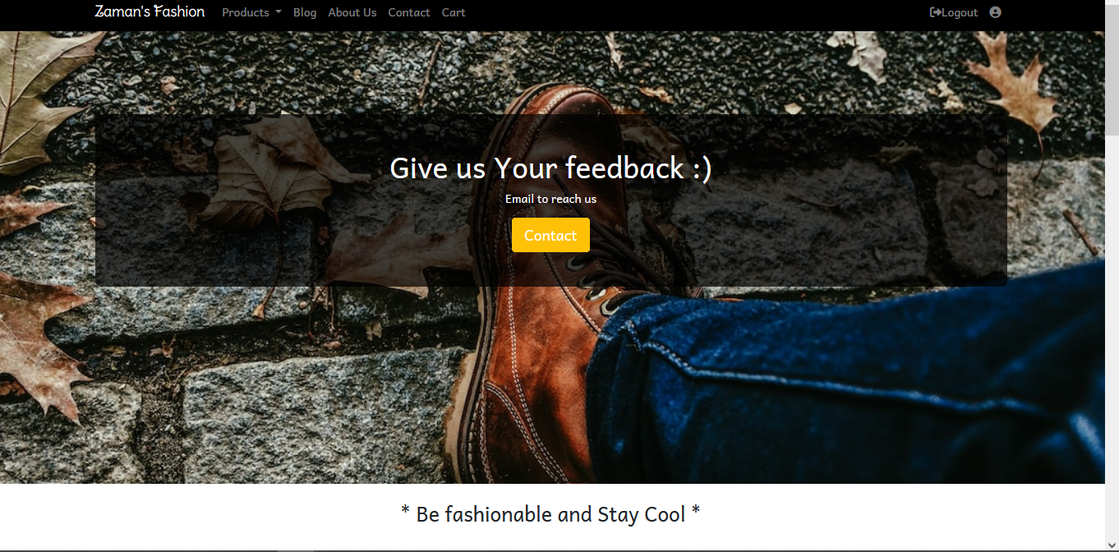

Figure 4.2.11: Contact page-I

In this page of the website shows the contact page. From this page customer can give feedbacks to the admin of the website. When customer click on the “Contact” button over the banner it will take him/her to the feedback section. From where customer can send any kind of messages through email by filling-up a simple form.

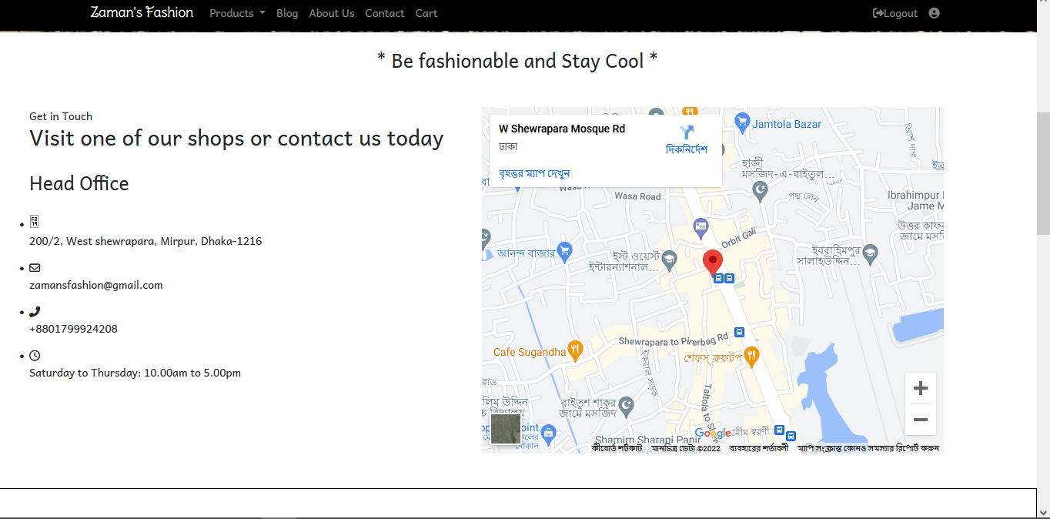

Figure 4.2.12: Contact page-II

This section of the contact page shows the address and contact details of the website customer care service and also shows the map location alongside the details.

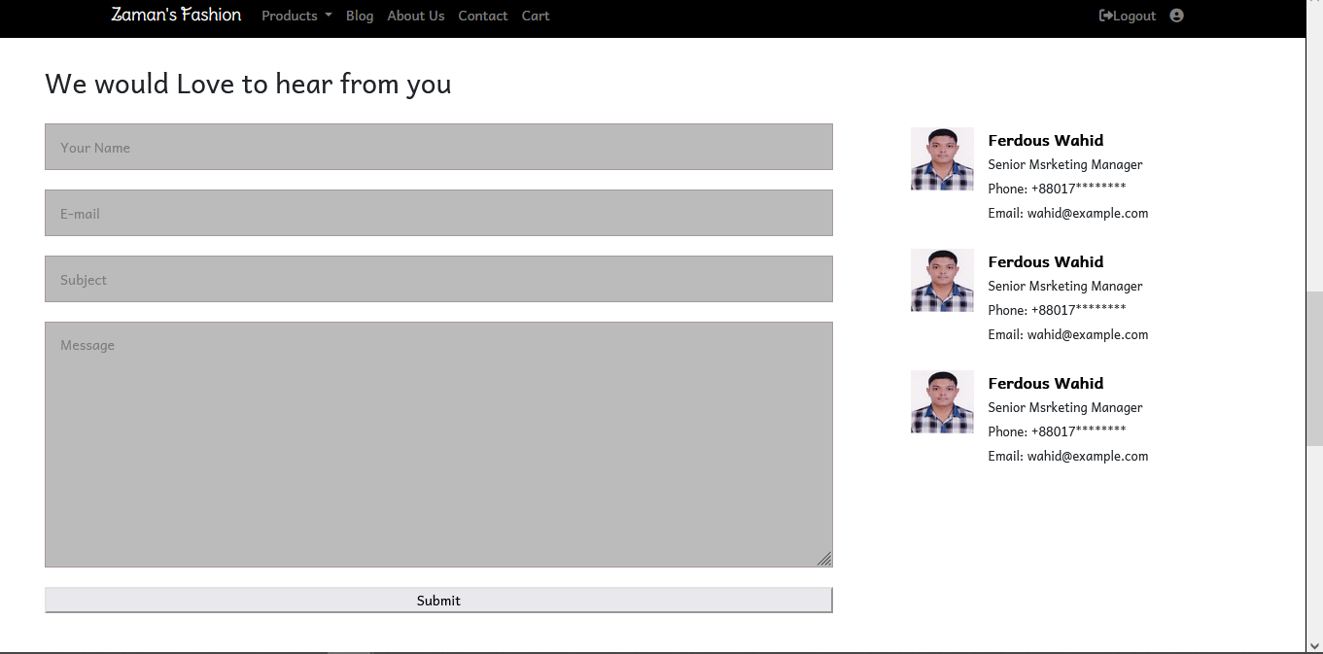

Figure 4.2.13: Contact page-III

From the above section of the page customer can send messages through email by filling-up the simple form and then click the “Submit” button to submit the feedback.

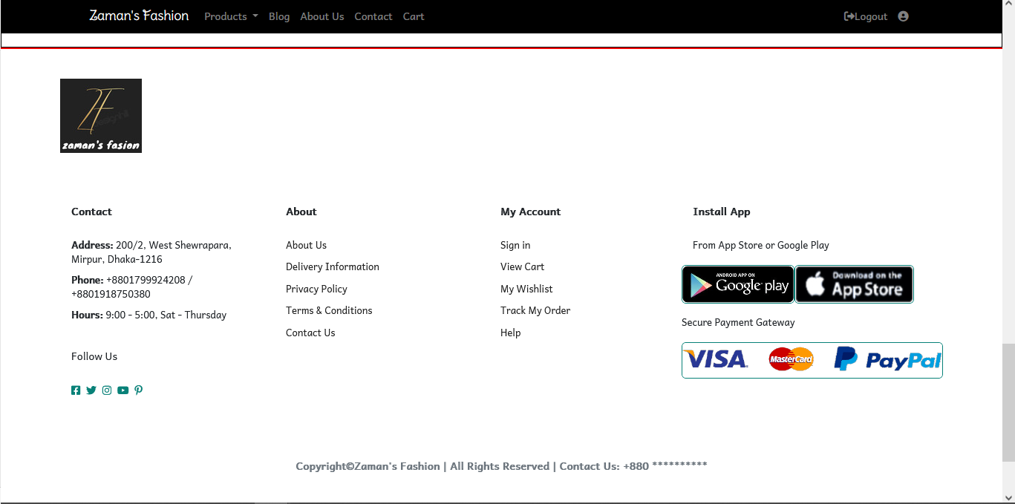

Figure 4.2.14: Contact page-IV

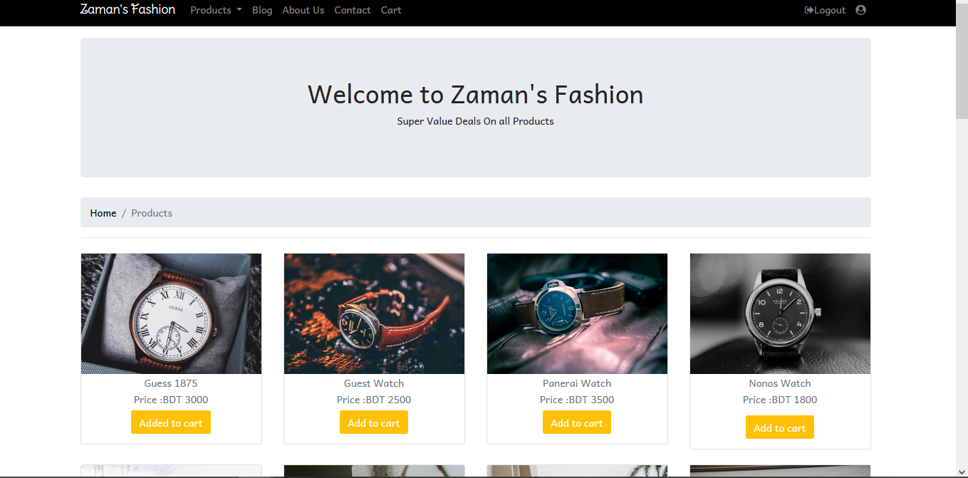

Figure 4.2.15: Product page-I

In this page, different category of products are featured. There is a drop-down bar in the nav-bar named products from which customers can go to the desired category of the product.

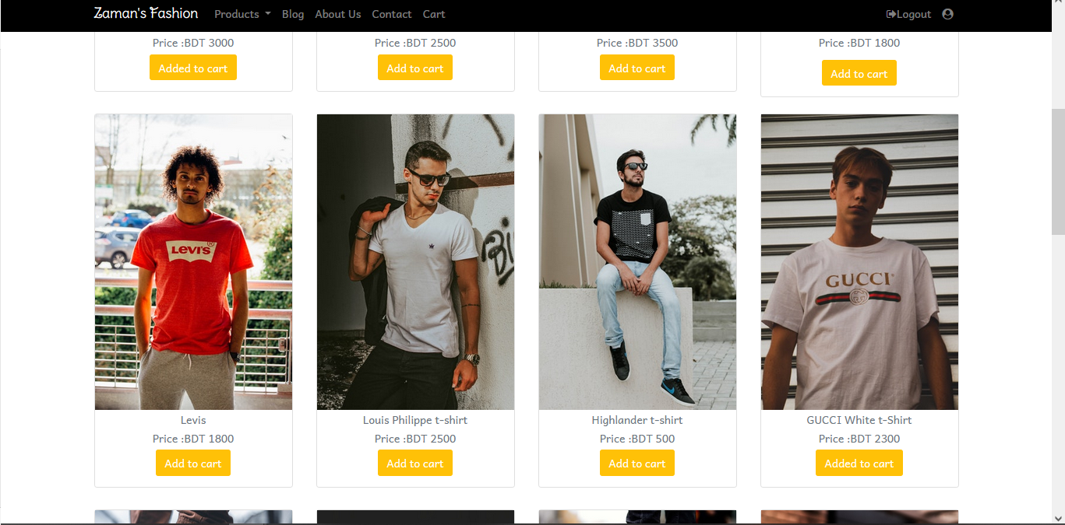

Figure 4.2.16: Product page-II

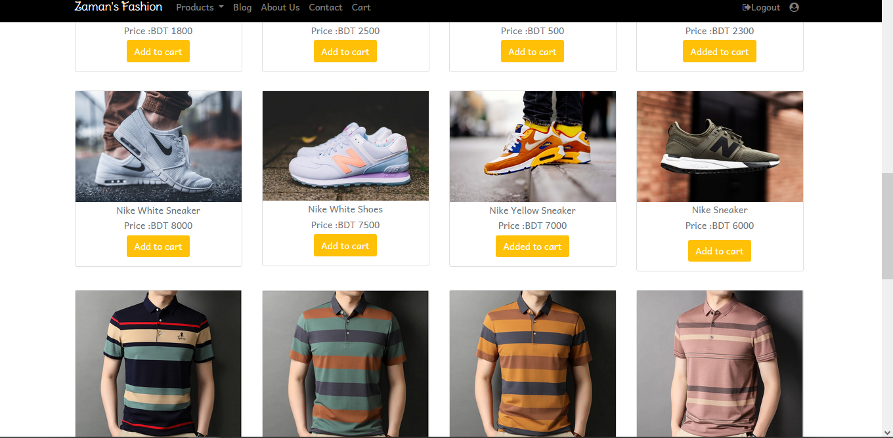

Figure 4.2.17: Product page-III

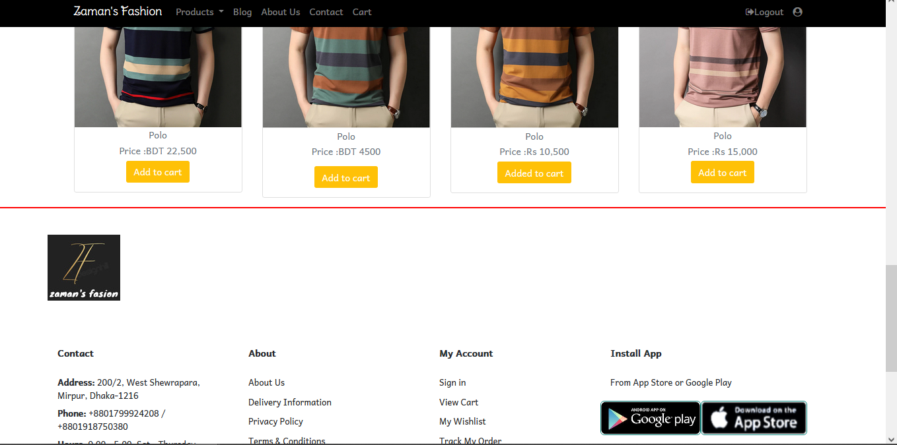

Figure 4.2.18: Product page-IV

At the end of the page there is the footer as always displayed. From the product page customer can order products by adding them into the cart and then confirm order from the cart page.

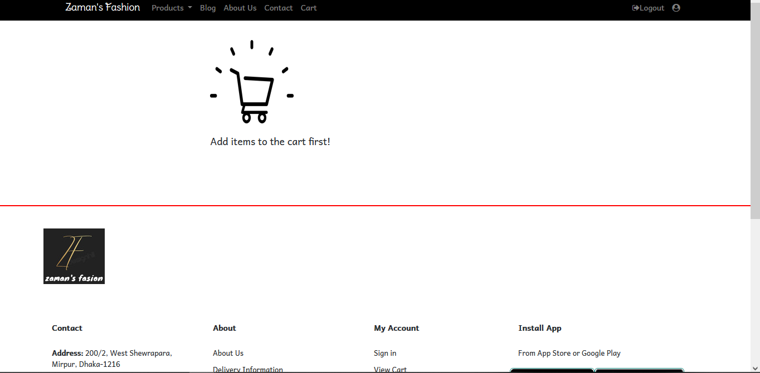

Figure 4.2.19: Cart page-I

This page is the cart page where the added products will be shown and customers can confirm their order from this page.

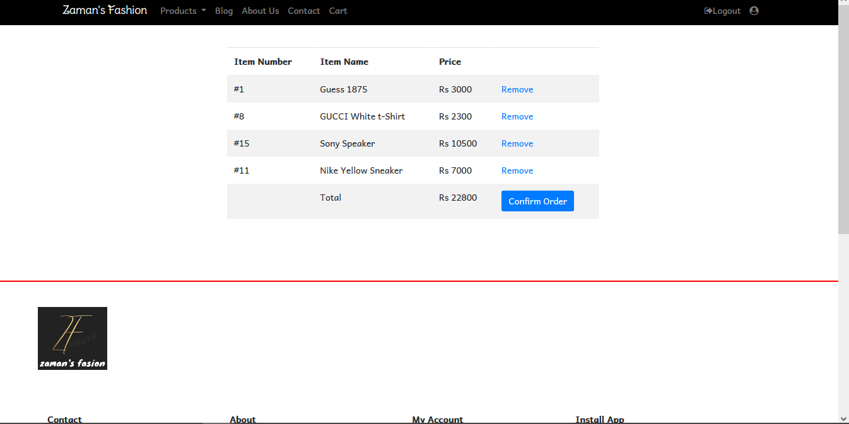

Figure 4.2.20: Cart page-II

After adding products to the cart, the cart will show the sum of the price of the added products as the total of orders.

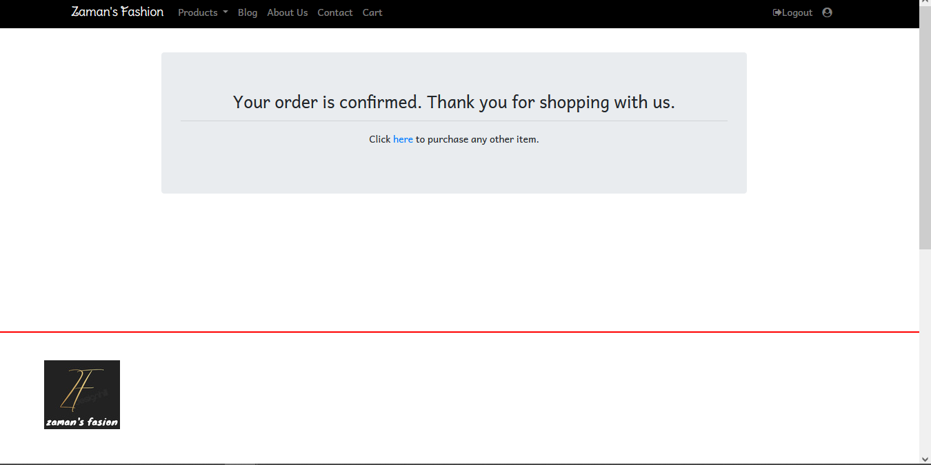

Figure 4.2.21: Cart page-III

After confirming the order there will be a pop-up message which is confirming that the order is confirmed and the shipping process has been started.

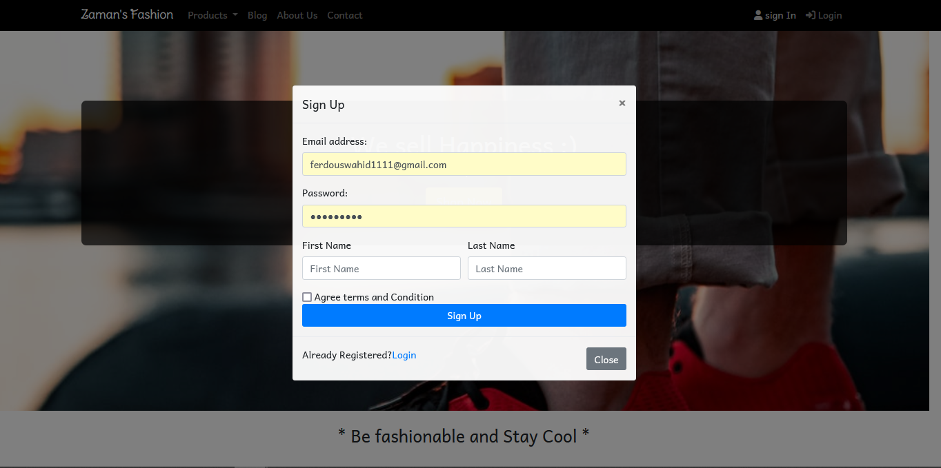

Figure 4.2.22: Signup Page

From the signup page customer can register a account so that he/she can walk through the rest of the process of ordering.

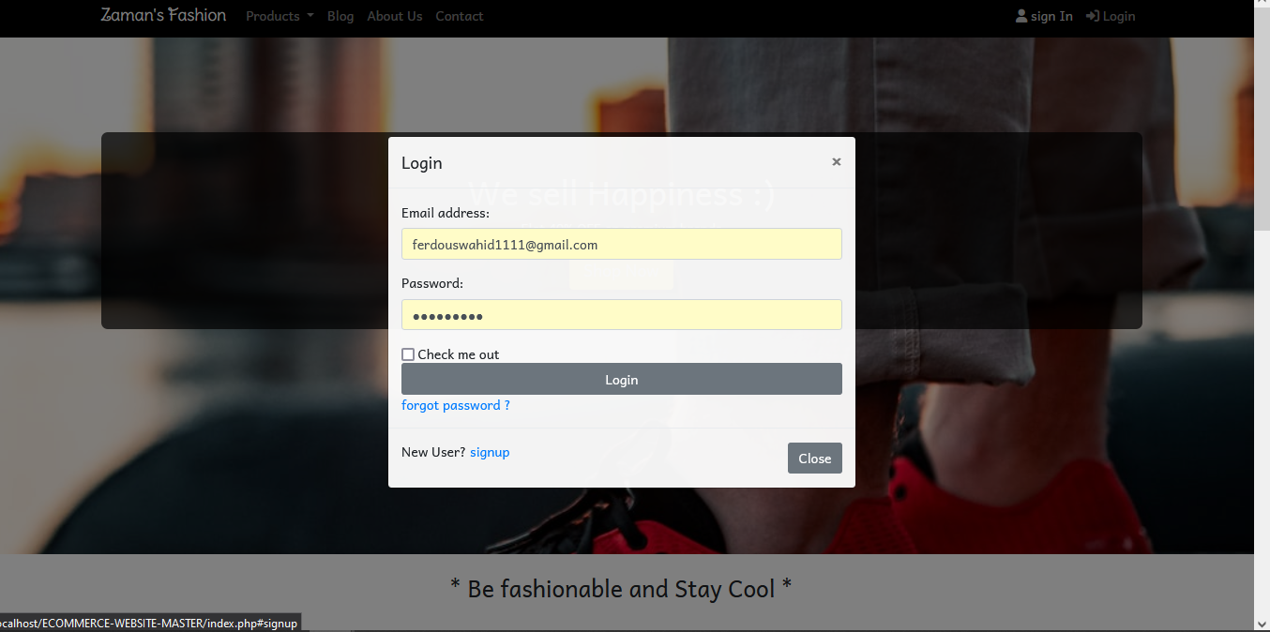

Figure 4.2.23: Login Page

After signup customer need to login. This is the login interface shown in figure 4.2.23.

**4.3 Database**

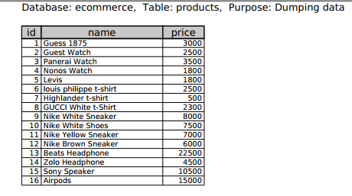

Table 4.3.1: Product Table

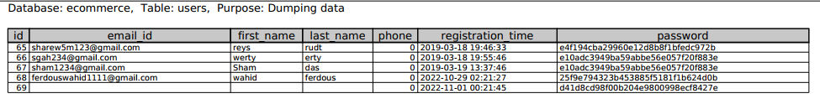

Table 4.3.2: User details Table

These three tables define the database details of the system.

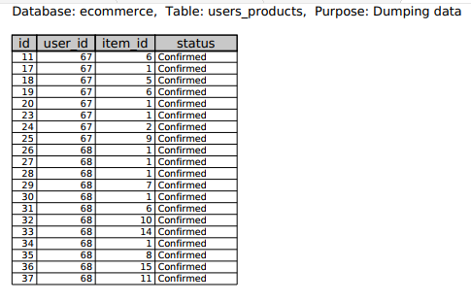

Table 4.3.3: User order details Table

**4.4 Conclusion**

In conclusion, we can see that there is a vast elaboration of html, CSS, Bootstrap, PHP languages to implement the code to get the desired output.

**Chapter 5**

**Conclusion & Future Work**

**5.1 Introduction**

This chapter describes the future scope and extensions for the project. There is still a huge scope of implementing something new and more to the project which can make it to the level of a commercial product. Our plan for this project to make it better in the future will be discussed in this chapter.

**5.2 Comparison**

There are significant differences between our project and the existing project. We had developed a responsive website which is an e-commerce selling platform where people can sell and buy products at the same time. On the other hand, existing platforms can’t satisfy these requirements. But our developed platform can provide best of services to both seller and buyer at the same time.

**5.3 Future Work**

In future, we have a plan to optimize our website for the people of all over the world. We will develop the system as per the region of the customers. According to the customers taste we will upgrade the products categories and prices and also give offers on their festive season. It will be very useful for the customer of that region of the world to get attracted to our platform of selling and buying products and services.

**5.4 Conclusion**

We have successfully implemented the website with the help of various research papers and web portals and tools. We have been able to provide source code of our project as an attachment with the report. We have been successful in our attempt to take care of the needs of both the user as well as the administrator. Finally, we hope that this will go a long way in popularizing.

**Reference**

**[**1] https://lvivity.com/web-based-applications

[2] https://www.techopedia.com/definition/26002/web-based-application

[3] https://docs.oracle.com/cd/E19146-01/821-1830/abxft/index.html

[4] https://www.itrobes.com/what-are-the-advantages-and-disadvantages-of-web-applications/

[5] https://www.freeprojectz.com/project-report/169

[6] https://www.w3schools.com/html/html_intro.asp

[7] https://www.w3schools.com/css/css_intro.asp

[8] https://business.trustedshops.com/blog/agile-methodology-help-your-online-shop